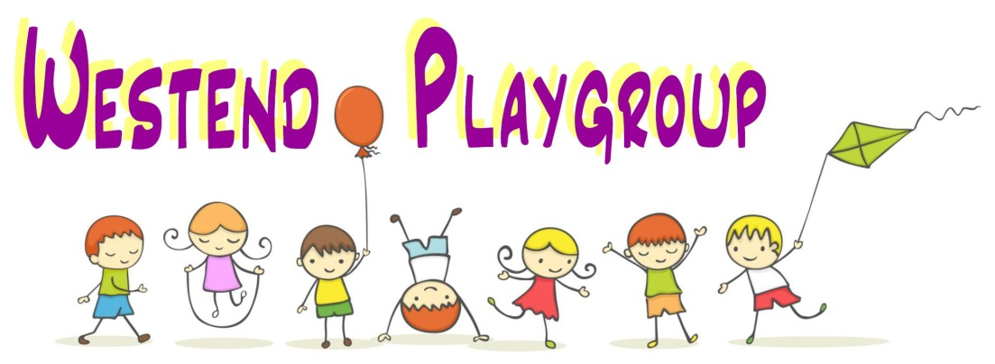
Healthy Eating
Westend Playgroup has been awarded the Gold Standard Health Snack Award. We recognise the relationship between healthy diet and lifestyle and a child’s ability to concentrate and learn. Within the setting, eating and drinking is a daily social activity shared between all children and the staff.
Westend Playgroup aims to provide nutritious snacks and drinks which are specifically tailored to children’s dietary needs where this is necessary, and foods include only those recommended by the Gold Standard Health Snack Award.
Prior to commencing in the setting parents/carers are required to complete a questionnaire detailing a child’s dietary requirements including allergies or intolerances. This information is recorded in a central file and transferred to a record held in the kitchen area for staff to refer to.
We have staff who are trained in nutrition and who hold a Food Hygiene Certificate.
We have a member of staff dedicated to taking responsibility for preparation of food and drinks for children with allergies and intolerances and the same member of staff remains with and supervises these children during snack time. We have staff who are trained in the use of an epipen.

Westend Playgroup applies the following practices:

- drinks include only water and milk and are provided in cups without lids;
- staff and children wash their hands before snack time;
- tables are cleaned with anti-bacterial cleaner before and after snack time;
- food is served on plates;
- children are offered a choice of foods which typically will include fruit, bread sticks, toast;
- staff and children eat and drink at the same tables to support the development of social skills and interaction;
- if parents/carers send in sugary snacks to celebrate birthdays etc then these are distributed to the children’s parent/carer at the end of the session to take home.

