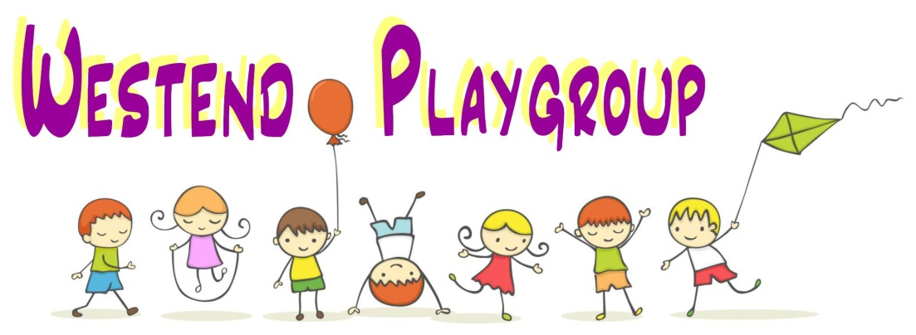
Health and Hygiene
Westend Playgroup will promote the good health of all children in its care, take positive steps to prevent the spread of infection and take appropriate steps when children are unwell.
Staff and visitors (including parents/carers) are not permitted to smoke or use electronic smoking devices within the building and are requested not to smoke or use electronic smoking devices in the car park or outside of the building.
The handling of food and drink complies with regulations relating to food safety and hygiene.
Children are provided with milk, fruit and healthy snacks during the morning. Fresh drinking water is also available. Children will be sat at tables in groups during this time under the supervision of staff.
On the Registration Form, we ask that you notify us of any allergies, your child’s likes and dislikes and what they prefer to drink from. We cater for allergies and operate a stringent process for ensuring that children do not come into contact with foods that they are allergic to. We also ask you to identify any healthcare needs that need addressing whilst in the setting.
Equipment Hygiene
- aprons/tea towels/cleaning cloths are hot washed daily;
- tables and chairs are cleaned before and after each use with anti-bacterial (Covid-19) spray;
- toys are inspected daily and cleaned/washed according to need.

Food Hygiene
- staff members attend food hygiene training;
- hands are always washed before handling food;
- food is not handled if staff are suffering from infections or skin problems;
- food preparation surfaces are cleaned before and after each use with anti-bacterial spray;
- different coloured cloths are used for cleaning kitchen and toilet areas;
- tea towels are hot washed between each session;
- utensils are kept clean and stored in a dust free closed drawer or cupboard;
- cracked/damaged utensils and equipment are disposed of;
- fruit and vegetables are washed before use;
- children comply with the above when involved in preparing food;
- daily checks are undertaken to ensure that the fridge temperature is within +2°C and +8°C.

Children are encouraged to learn about personal hygiene i.e. hand washing when visiting the toilets, cooking and after messy play.
Personal Hygiene
- tissues are available to children who are encouraged to blow and wipe noses and dispose of tissues hygienically;
- children are encouraged to cover their mouths when coughing and sneezing;
- children are accompanied to the toilet and changed into clean and dry clothes if wet or soiled;
- help is given to children where necessary; children are supported to become independent in their use of the toilet;
- steps, trainer seats, changing facilities and adequate toilet facilities are available;
- the toilet door is kept open whilst a member of staff is present with a child;
- when a child’s nappy needs to be changed, the member of staff sign and date a record of the nappy being changed;
- children will be taught good hygiene practice; wiping, flushing and hand washing;
- air dryers and disposable paper towels for hand drying are available;
- single use aprons and gloves are used by staff for use when changing children’s nappies or dealing with sickness and diarrhoea.

Cleaning and clearing up
- tables are cleaned before and after each use with anti-bacterial spray;
- blood, vomit, excrement will be wiped up with paper towels which are disposed of in the toilet; soiled surfaces are disinfected;
- soiled garments will be double bagged and returned home with the child;
- gloves and aprons will be used by staff when cleaning up bodily fluids.

Outdoor play
- children will have the opportunity to play outside, in the local community or at places of interest;
- the immediate outdoor area will be checked before children are allowed to use it;
- all outdoor play is supervised;
- parents/carers will be asked to provide suitable protective outdoor clothing for different weathers and when required sunscreen products are to be applied before attendance at playgroup.

Illness
Three members of staff are trained in the administration of First Aid and the premises has a fully equipped First Aid box which is accessible to staff only.
On the Registration Form, we will ask you to disclose the date of your child’s last tetanus injection and allergies.
We will request your signature as permission to apply a plaster if necessary and also your signature giving permission for your child to be given emergency medical treatment which may be necessary.
In our contract with you, you agree to not send your child to Playgroup if unwell. If your child is suffering from diarrhoea, vomiting, fever (101° F or 38° C) and has been unwell with these symptoms during the night, please keep your child home for 48 hours and contact your GP.
If your child has a contagious disease such as chicken pox, impetigo, or other notifiable disease, or nits or worms, please inform the Playgroup Leader and do not send your child to Playgroup. We will notify parents of other children, without breaching confidentiality.
In the event your child becomes unwell during Playgroup, the Registered Person will contact the parent or other named person, using the telephone numbers you have given, and arrange for your child to be collected. Whilst remaining in playgroup, care will be taken to prevent infection of other children and staff members.
The Registered Person will, if appropriate, seek advice from the Health Protection (All Wales Acute Response) Team on 0300 00 300 32.
Exclusion Periods of the common infections
Rashes and skin  infections | Recommended minimum  period of exclusion | Notes
Chicken Pox | 5 days from onset of  rash and until all  (blisters) vesicles  have crusted over | Chickenpox can affect pregnancy if a woman has not already had the infection. Report exposure to midwife and GP at any stage of pregnancy. The GP and antenatal carer will arrange a blood test to check for immunity. Shingles is caused by the same virus as chickenpox, so anyone who has not had chickenpox is potentially vulnerable to the infection if they have close contact with a case of shingles.
German  Measles  (Rubella) | Five days from onset of rash | If a pregnant woman comes into contact with german measles she should inform her GP and antenatal carer immediately to ensure investigation. The infection may affect the developing baby if the woman is not immune and is exposed in early pregnancy.
Impetigo | Until lesions are crusted and healed, or 48 hours after commencing antibiotic treatment
Measles | Four days from onset of rash | Measles during pregnancy can result in early  delivery or even loss of the baby. If a pregnant  woman is exposed she should immediately  inform whoever is giving antenatal care to  ensure investigation.
Mumps | Exclude child for five days  after onset of swelling
Scabies | Until after first treatment
Scarlet fever | 24 hours after commencing  appropriate antibiotic  treatment
Shingles | Only keep away if rash is  weeping and cannot be  covered | Can cause chickenpox in those who have not  had chickenpox

Exclusion periods for common respiratory illnesses
Illness | Minimum Period of Exclusion
Respiratory infections including Covid-19 | Individuals should not attend if they have a high temperature and are unwell.  Individuals who have a positive test result for COVID-19 should not attend the setting for 3 days after the day of the test.
Flu | Until recovered
Tuberculosis | Consult Health Protection Team
Whooping Cough (Pertussis) | 48 hours from commencing antibiotic treatment, or 21 days from  onset of illness if no antibiotic treatment.  After treatment, non-infectious coughing may continue for many  weeks.

Exclusion periods for other infections
Infection | Minimum Period of Exclusion
Diptheria | Must not attend setting. Consult Health Protection Team.
Ear and eye infections | None - Health Protection Team can advise.
Hepatitis A | Until 7 days after onset of jaundice (or seven days after symptom onset if no jaundice).

If a child or member of staff has sickness and diarrhoea, they must leave the setting and not return until 48 hours after the last bout.
If you request that we administer medication to your child, we will do so only with your written agreement and an understanding of the possible side effects of the medication. You will be asked to complete and sign a request form.
If regular medication is required, staff will require consultation and training from the child’s GP or Health Visitor.
Due to only being open for 2 ¾ hours per day we will not administer painkillers or antibiotics. Please do not send your child to Playgroup until 48 hours after an initial dose of antibiotics.
We will apply creams/lotions and use inhalers (once you have shown us how to use the equipment).
All medicines must be stored in their original packaging and clearly labelled with the child’s name and dosage.
The dosage, time and who administered the medication will be recorded on written record which the parent/carer will be required to sign when collecting their child, to acknowledge that the child has received the medication.
Please refer to the medication policy in relation to the ongoing administration of medication

