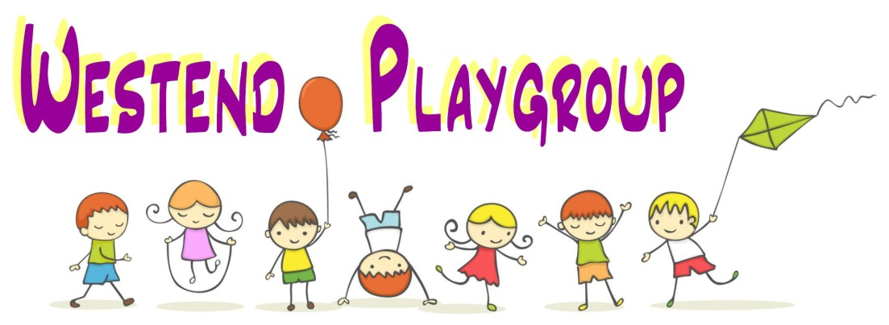

Safeguarding and Child Protection Policy and Procedure
Safeguarding of Children is our first priority, and it is everybody’s responsibility.
The Children Act 1989 and the UN Convention on the Rights of the Child, are adopted by the Welsh Assembly Government as the basis for its work with all children and families in Wales (All Wales Child Protection Procedures, 2008).
The purpose of having a safeguarding and child protection policy is to protect children, the interests of staff and uphold the requirements of the legislation, statutory guidance and relevant national procedures and protocols; these include the Care Standards Act 2000, the Children Act 1989, the Social Service and Wellbeing Act (2014), Working Together to Safeguard People (as updated), Keeping Children Safe in Education (as updated) and the Wales Safeguarding Procedures (as updated).
This setting aims to provide an environment in which children are safe from harm and abuse and in which all suspicions of physical, emotional, sexual abuse and neglect will be responded to in accordance with the Wales Safeguarding Procedures (as updated) and the local procedures of the Cardiff and Vale of Glamorgan Regional Safeguarding Board.
The welfare of the child is of paramount importance and the following safeguards are put in place to support this principle.
Staff, volunteers and students
All staff and volunteers will hold enhanced DBS disclosures which will be updated every 3 years. Any person about whom there are concerns in relation to children will not be appointed in any role within Westend Playgroup.
Students and volunteers who do not have up to date DBS disclosures will be closely supervised and will not have any unsupervised access to children within the setting.
All appointments, whether paid or unpaid, will be subject to an interview, two positive references, one of which must detail the applicants’ suitability to work with young children, and will be subject to a probationary period during which suitability to work with young children is monitored and assessed.
All new employees of Westend Playgroup will be notified to the Care Inspectorate Wales (CIW).
Training
A current volume of the Wales Safeguarding Procedures is accessible online and will form the basis for safeguarding training.
Staff and volunteers receive safeguarding training at Level 2 or Level 3 according to their role, which enables them to recognize signs and symptoms of child abuse and how to respond to concerns.
Good practice within the setting
The Playgroup Leader has ultimate safeguarding responsibility in the setting, delegated to the Deputy Playgroup Leader in her absence.
Staff have the welfare of children uppermost in their mind and will use the procedures to ensure that children are kept safe.
Children will be supervised at all times by a responsible adult and will not be left alone with students, visitors or any adult who is not deemed able to be responsible for the child.
Children will never be punished by smacking, slapping or shaking. Children will not be made to feel humiliated, degraded or undervalued.
Children will only be handed over to an adult that the setting has been notified of by the parent/carer.
Record keeping
Concerning changes in a child’s behaviour, demeanour or physical presentation, including the presentation of injuries, will be recorded in writing and shared with parents/carers and statutory agencies if necessary.
The record will be factual and include observations and not interpretations. If a child tells staff something that causes concern, this will also be recorded in writing using the child’s exact words.
All written records will be kept confidential within the setting and shared with statutory agencies if concerns exist.
Child Protection Procedures
If abuse is suspected or alleged by others, the worker informs the playgroup leader. The information given is written up and passed on the same day to the statutory agencies (social services/police). The Playgroup Leader is responsible for making referrals to statutory services.
Consent will be sought from parents if the referral concerns a child in need. If it is a child protection matter, no consent is required as to involve the parents or refusal to make the referral might compromise the safety of the child.
Information will be shared with families, unless to do so would compromise a child’s safety as directed by statutory agencies. The setting works in partnership with statutory agencies to reach agreement about what information can be shared with families. Records about children and reasons for withholding information is recorded by the Playgroup Leader and held securely in a locked cupboard. Parents are entitled to read records unless to do so would compromise the safety of the child.
Suspicions against a member of staff or volunteer
If a member of staff is suspected of abusing a child or an allegation of this nature is made it will be immediately referred to the statutory agencies and the staff member will be dealt with under the disciplinary procedure, pending the outcome of the investigations of the statutory agencies and internal enquiries of the setting. CIW will be notified of the allegation, actions taken by the setting, outcome of any statutory agency investigations and final actions of the setting.

Contact Numbers
Social Services – 01446 725202 (out of hours 02920 788570)
Police – 02920 222111
NSPCC Cymru/Wales Helpline – 0808 8005000

