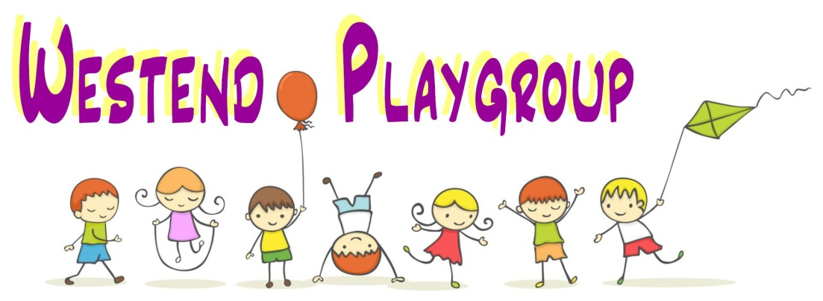
Smoke Free Policy

At Westend Playgroup we take seriously our duty to promote children and young people’s wellbeing and their spiritual, cultural, moral, social, and cultural development. We see our commitment to creating a smoke-free and vapour free environment and developing pupil’s knowledge, attitudes and skills in decision making around smoking as part of our work on keeping children safe around drugs and managing risk. Our setting is committed to educating around the dangers of substance misuse which includes tobacco.
Purpose
Our aim is to ensure a whole-setting approach to tobacco and vaping to protect all members of the setting from the harms of second-hand smoke and to prevent the normalcy of vaping and smoking. We hope that implementing this will reduce the prevalence of smoking across the whole setting community. By making these steps our setting will also be meeting Healthy Schools NQA Standard 11 for Substance Use and Misuse by ensuring smoking is banned on school premises and grounds and E-cigarettes are included in smoking policies and are treated in the same way as tobacco products.
The Public Health Wales Act (2017makes it illegal to smoke on school ground, hospital grounds and play-grounds.
Policy
It is the policy of Westend Playgroup to comply with the above regulations in making our setting a no-smoking environment - both inside and outside the building including any grounds.
Nicotine is highly poisonous to children. All smoking products and accessories, including electronic cigarettes and ‘vaping’ equipment, should be stored out of sight and out of reach of children. This includes those carried in bags and other personal belongings.
All staff are required to abide by and help with the implementation of the policy.
Objectives:
- To provide a smoke and vape free school environment for the whole setting community;
- To ensure that tobacco education is part of the setting’s curriculum of drug education/PSE (including the health effects and social aspects of tobacco use);
- To ensure that staff have all the knowledge and understanding of policies, procedures and agreed practice to support the implementation of the Smoke Free Policy;
- To involve all staff, pupils, parents/carers and members of the wider setting community including outside agencies as appropriate in the development of policy and practice in relation to tobacco;
- To adopt and support interventions that aim to prevent the uptake of smoking amongst pupils, staff, parents/carers, contractors and members of the wider setting community;
- To ensure that staff, parents/carers and members of the wider setting community are aware of the potential knock-on effects of e-cigarettes which may act to ‘normalise smoking’;
- To assist staff and other members of the setting community who smoke and wish to stop.
- To ensure that the Schools Smoke Free Policy is applied when children/young are taken off site.
Rationale:
- All members of the setting community have the right to work and learn in a smoke free environment;
- Exposure to second-hand smoke (passive smoking) increases the risk of lung cancer, heart disease and other illnesses. Exposure to role models who smoke also normalises smoking behaviour, which can have a significant negative impact on the delivery of the smoke-free message;
- E-cigarettes may normalise the act of smoking for those that have never smoked and influence the take of similar behaviours;
- Young people who have not previously smoked cigarettes may try e-cigarettes, young people may be influenced by adults smoking e-cigarettes;
- Mixed messages around e-cigarettes add to the attraction of using them;
- Various flavours of e-cigarettes lead to their increasing appeal;
- Some E-cigarettes can contain nicotine and there is some concern over young people being exposed to nicotine at an early age. Nicotine is a highly addictive substance;
- Smoking remains the largest preventable cause of death and illness in Wales.
Procedures
This policy applies to students, staff, parents/carers, and members of the public, contractors or others working/using the playgroup premises and all vehicles used to transport children. Smoking is not permitted in any part of the playgroup premises and car park. Smoking is not permitted in any setting owned/hired or leased vehicles as well as private vehicles when carrying children or staff on playgroup business. This policy applies when children are taken off site on school excursions/visits/trips. Staff and accompanying helpers will be reminded that smoking is not permitted when on duty. Employees are not permitted to smoke on site at all.
- all staff, parents, volunteers and visitors will be made aware of our no-smoking policy;
- we will display ‘No-Smoking’ signs in prominent positions so that people can see them;

Non – compliance in respect of parents/carers/visitors
- we will draw the person’s attention to the ‘No Smoking’ signs and remind them that they are committing an offence. The person will politely be asked to stop smoking and advised where they can smoke;
- we will explain that the setting has a smoke free policy and it is an offence for anyone to smoke in the building;
- if ignored, the person will immediately be asked to leave the premises;
- we will maintain a record of all such incidents and outcomes.

Help with Stopping Smoking
The following sources of support are available for smokers who want to stop:
Free Help Me Quit helpline on 0800 085 2219
Quit Smoking Services In Your Area | Help Me Quit

