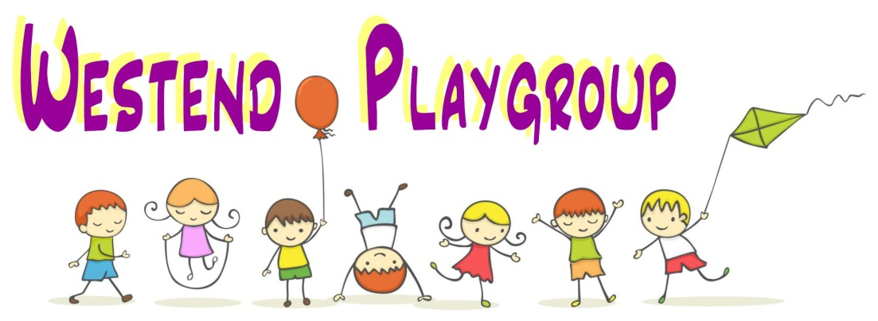
A CHARTER FOR CHILDREN AT WESTEND PLAYGROUP
Westend Playgroup prides itself on prioritising the happiness and well-being of children in our care.
- On arrival, children are welcomed cheerfully and greeted using their first name.

- If upset, children are free to choose who they want to be comforted by.

- It is fine to bring in a specific ‘comfort’ item where this helps the child settle into the routine of the playgroup.

- If the child discards their comfort item, it will be put in the basket, so the child can see it and retrieve it at any time throughout the session.

- Children do not have to participate in any activity if they do not want to. We will encourage involvement but never force a child to do something. If the activity is baking or creation of a craft item, staff will make the item so that the child has something to take home at the end of the session. Parents will be informed if the item has been made by a member of staff.

- The staff will not shout at, smack, ridicule, humiliate, threaten, isolate or make a child feel unwanted or undervalued.

- The staff will always act as good role models in their behaviour by showing courtesy, respect, tolerance, patience, kindness and concern to children.

- The staff do not use the term ‘naughty’ and simply say ‘no thank you’ to discourage unwanted behaviours.

- The staff will not physically handle children to manage disruptive or unwanted behaviour but will offer their hand to hold and lead the child to a different activity. In the event a child’s behaviour is causing harm to themselves or another child, if necessary, staff will gently and safely pick the child up, to move them to a safe place.

